**Lab Exercise 3– Terraform IAM User Setting**

**Prerequisites: Terraform Installed: Make sure you have Terraform installed on your machine. Follow the official installation guide if needed.**

AWS Credentials: Ensure you have AWS credentials (Access Key ID and Secret Access Key) configured. You can set them up using the AWS CLI or by setting environment variables.

Search IAM then click on users tab and create a new user

**Output of Aws Credentials :-**

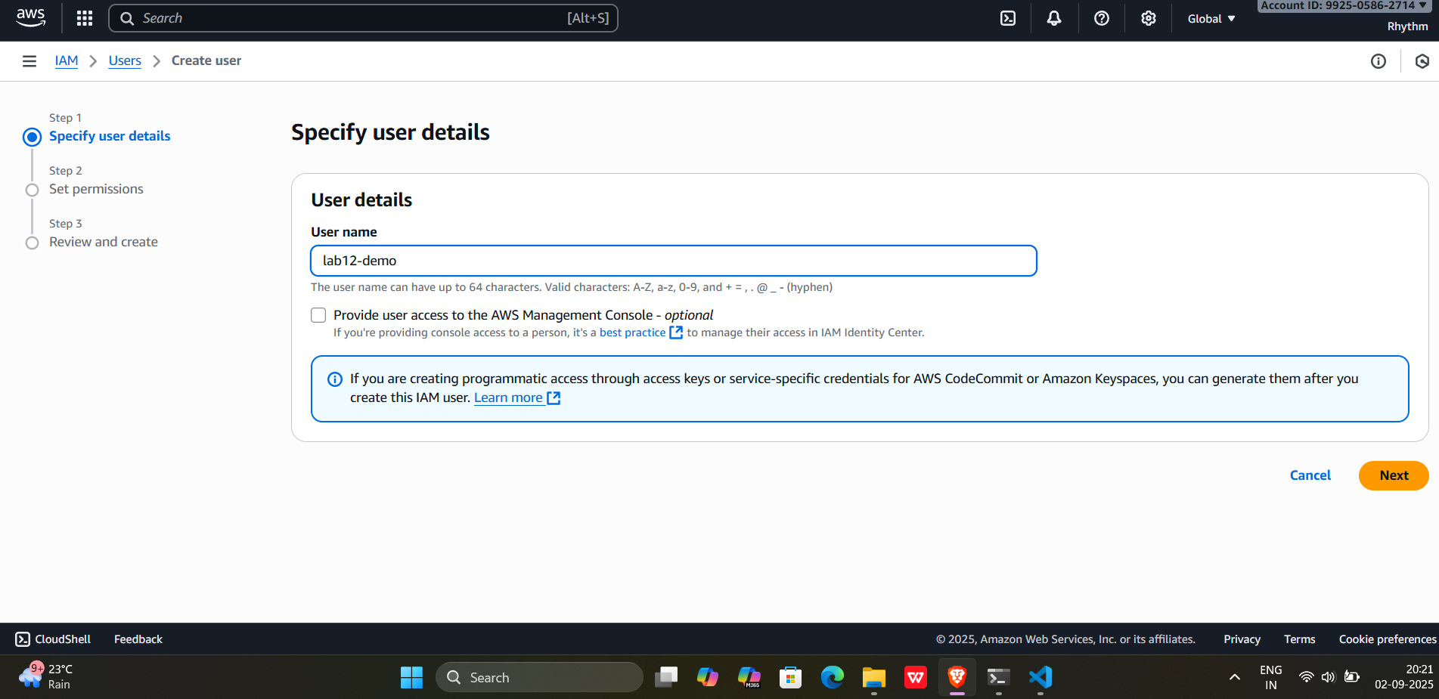

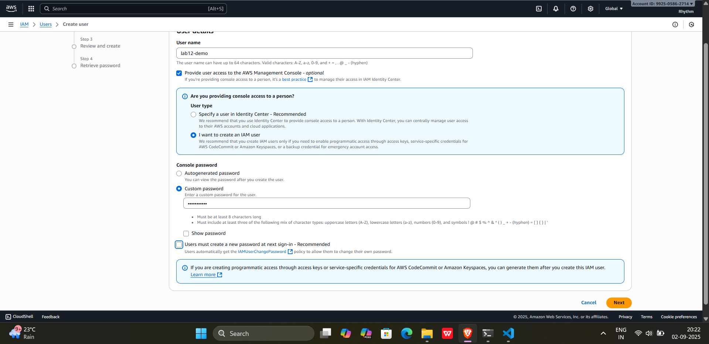

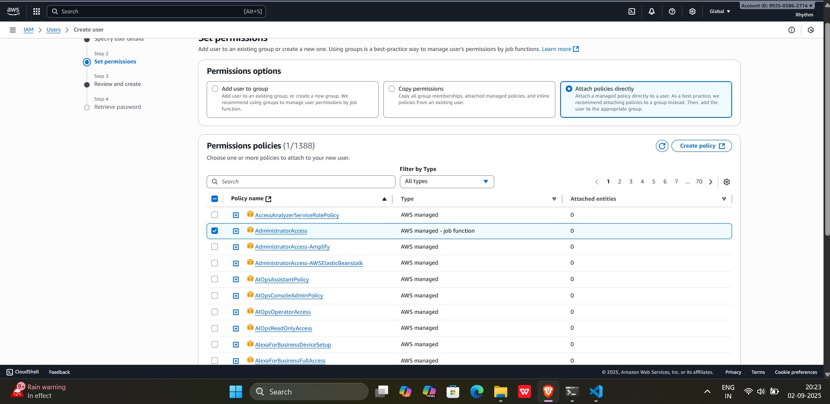

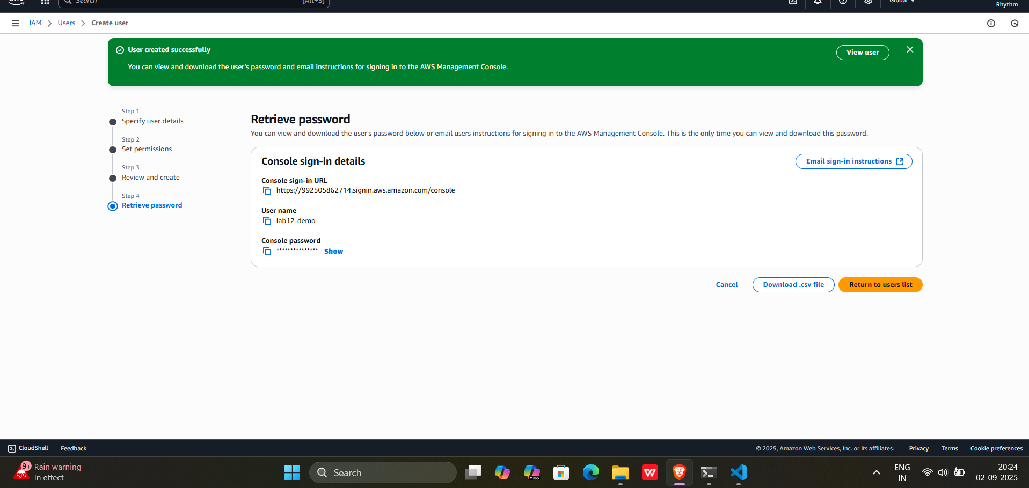

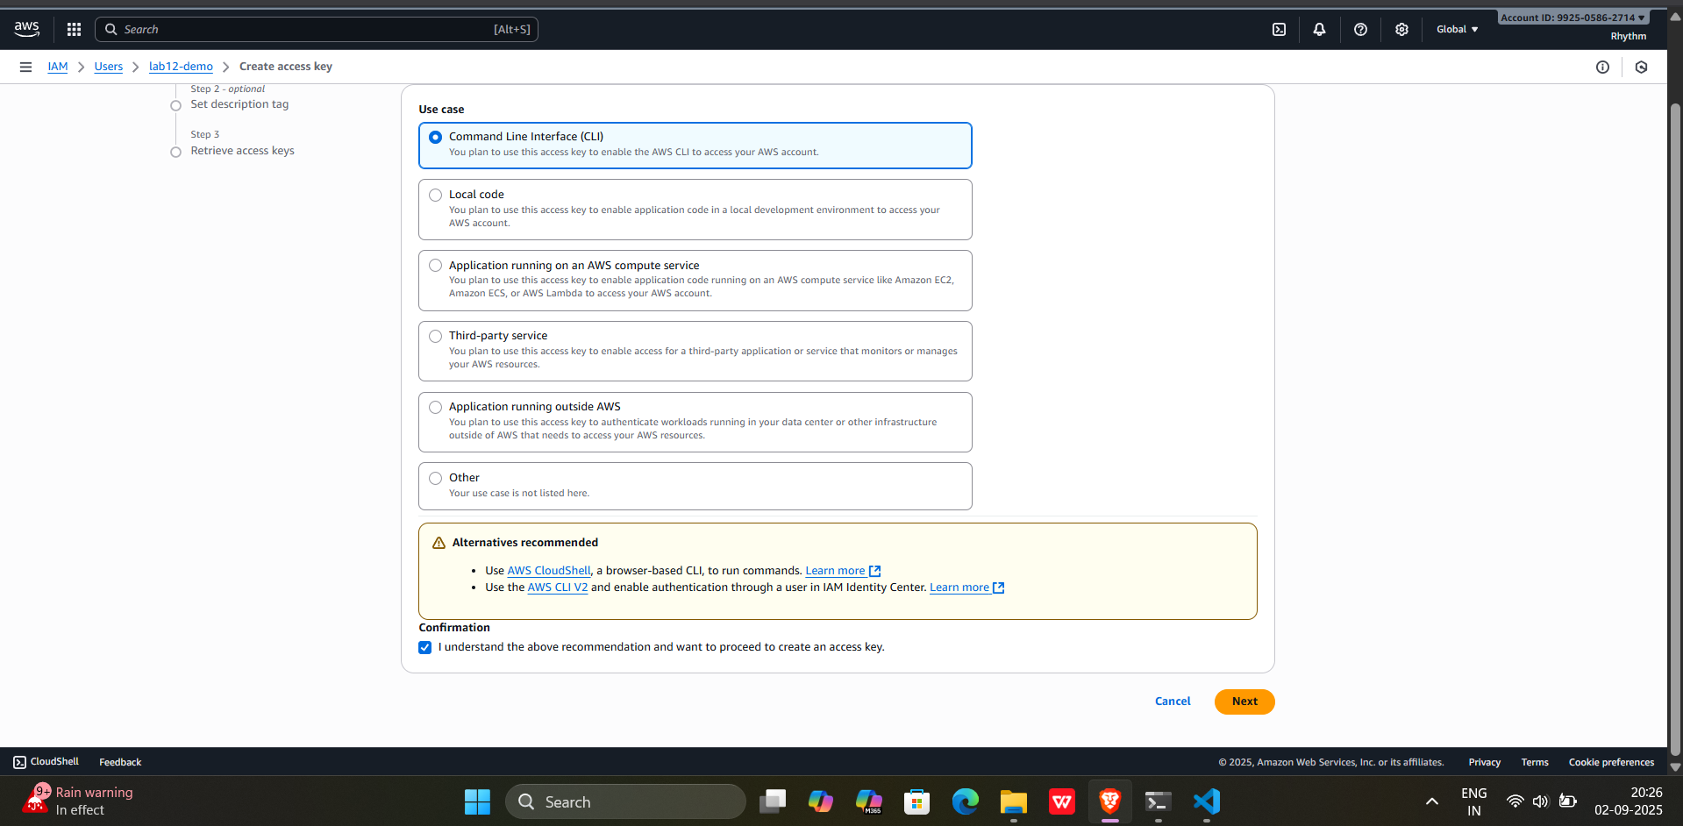

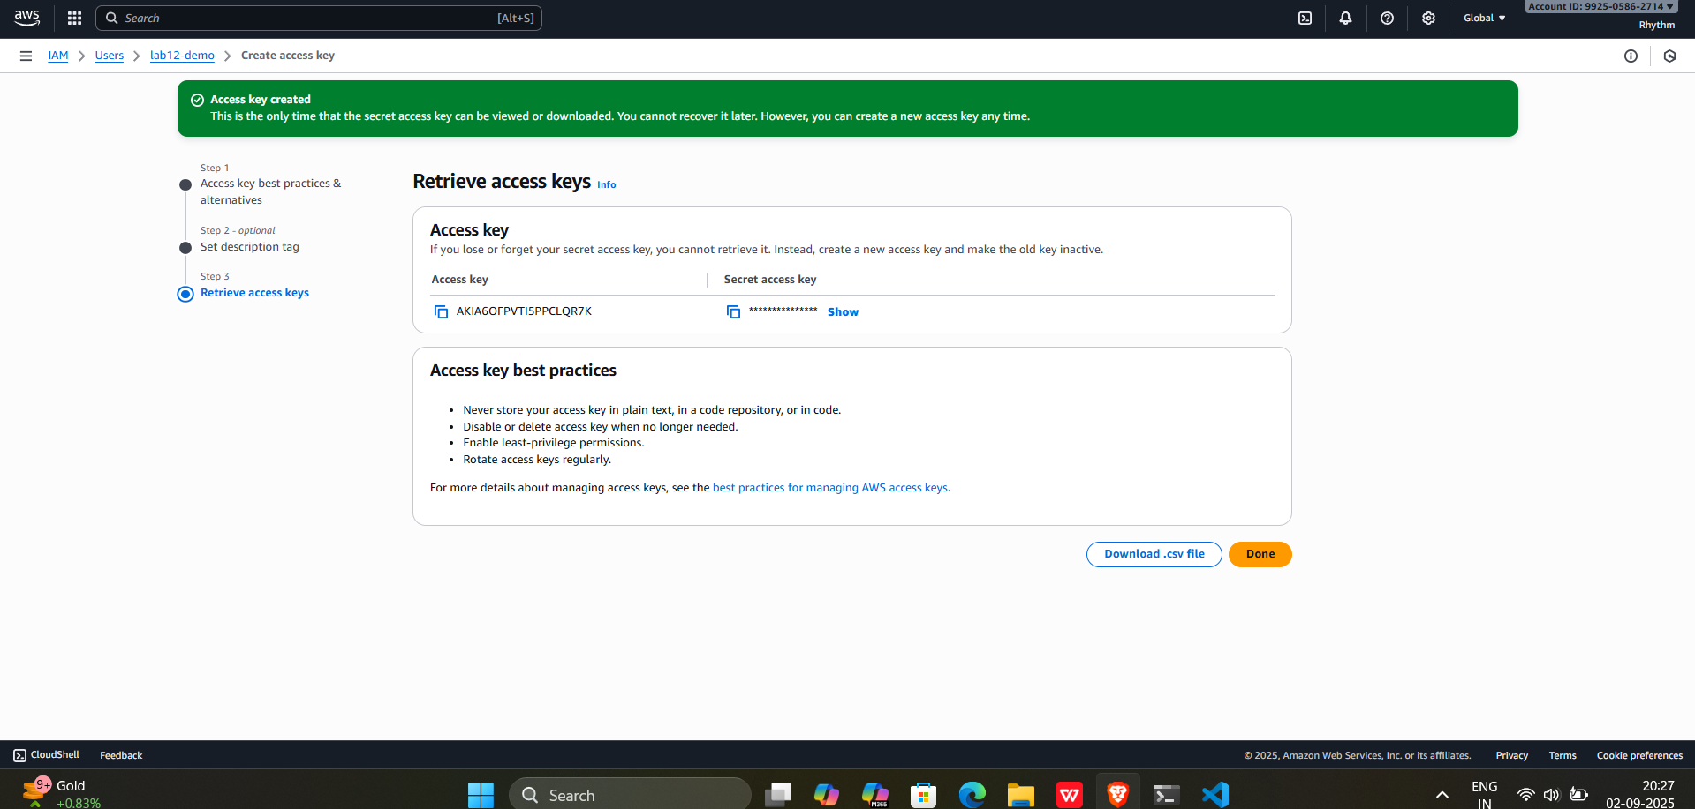

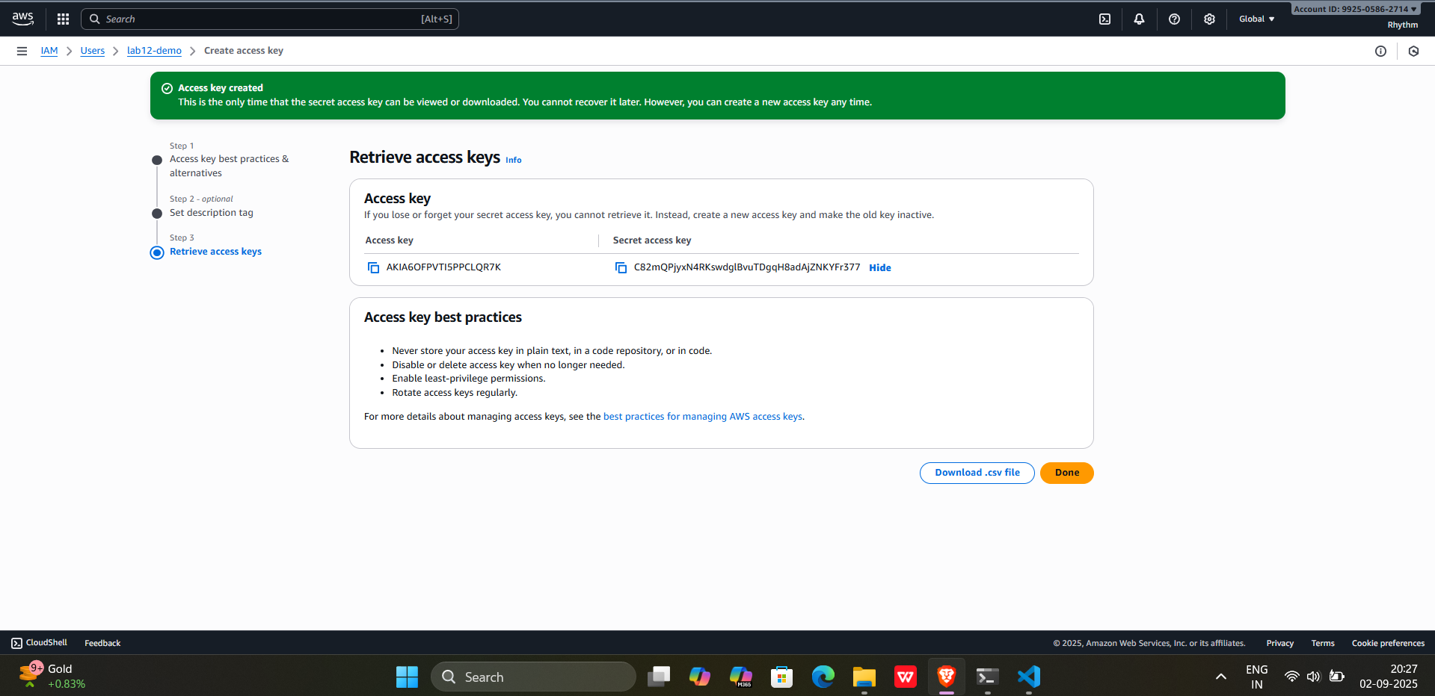

**Exercise Steps:**

**Step 1: Create a New Directory:**

Create a new directory for your Terraform configuration:

“**Terraform-Demo”**

**Step 2: Create Terraform Configuration File (main.tf):**

Create a file named main.tf with the following content:

terraform {

  required_providers {

    aws = {

      source = "hashicorp/aws"

      version = "5.31.0"

    }

  }

}

provider "aws" {

  region     = "ap-south-1"

  access_key = "your IAM access key"

  secret_key = "your secret access key"

}

This script defines an AWS provider and provisions an EC2 instance.

**Output:-**

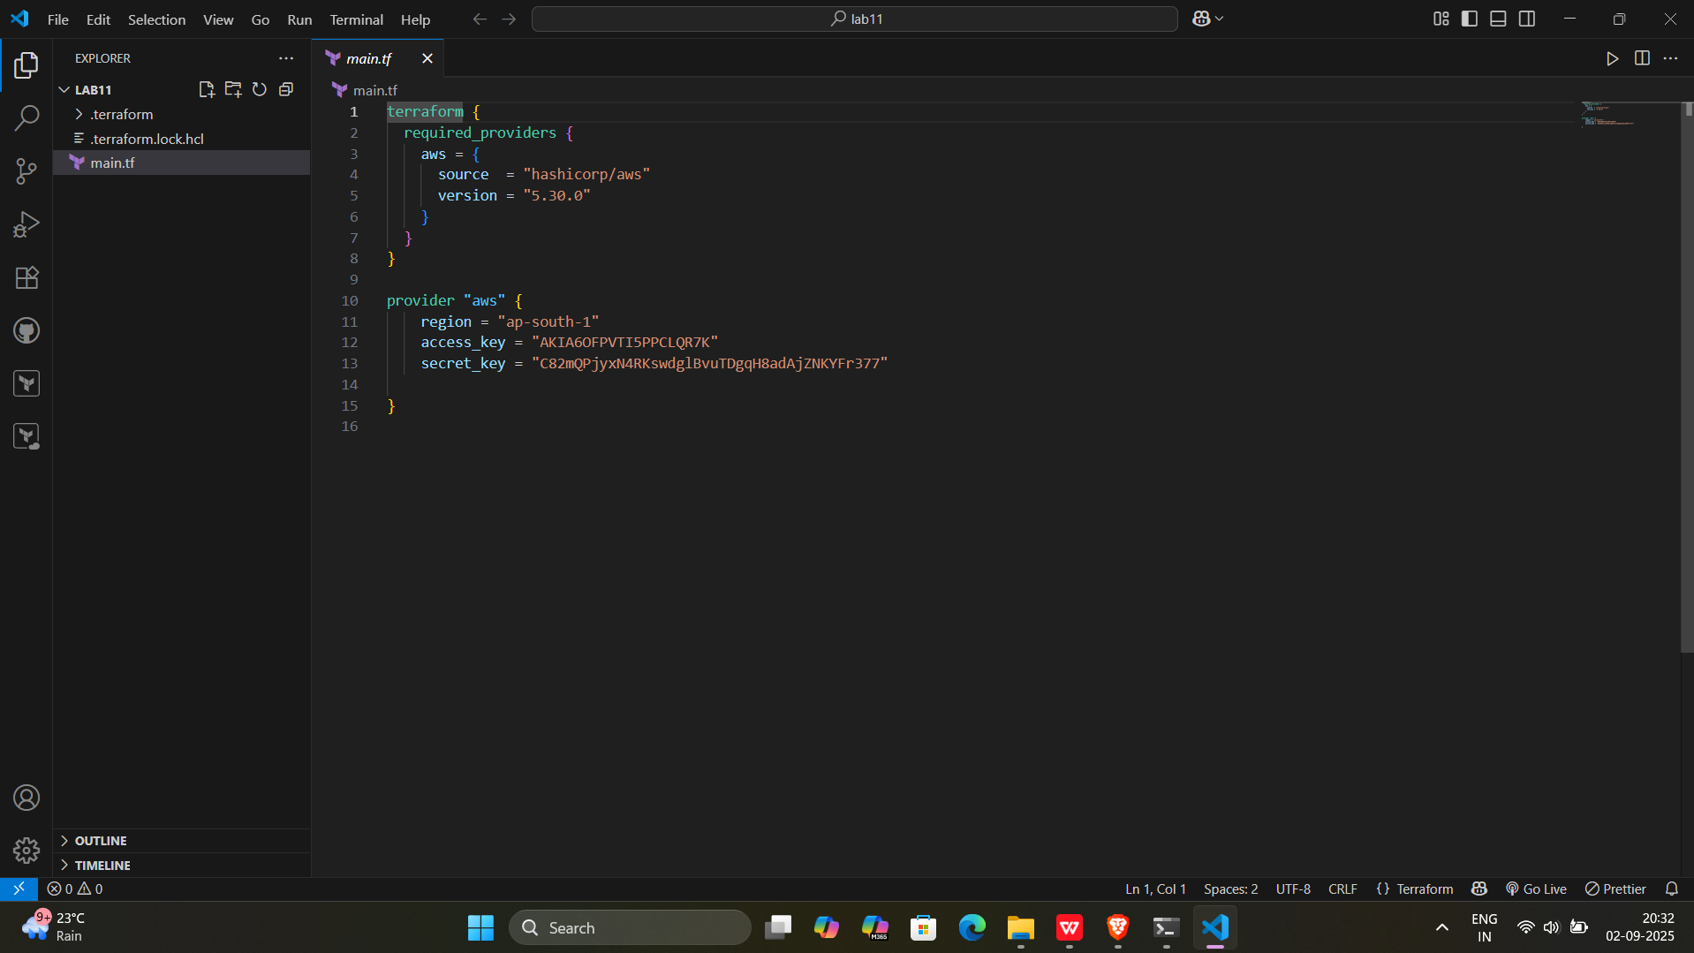

**Step 3: Initialize Terraform:**

Run the following command to initialize your Terraform working directory:

terraform init

**Output:-**

